
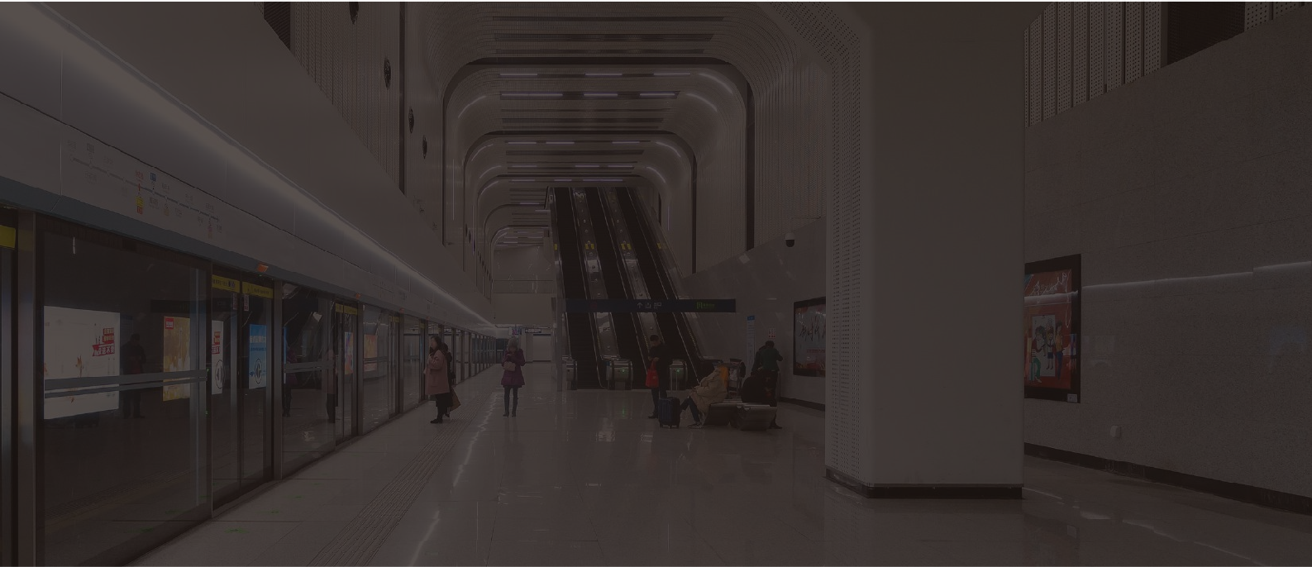
JR301-SC-IW-SIP

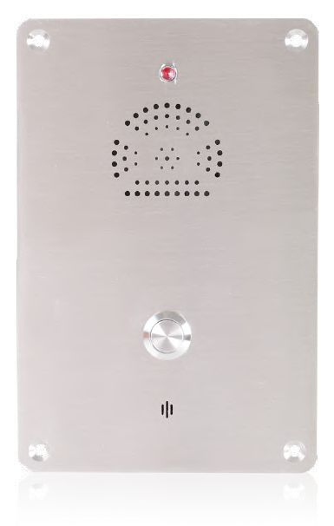

Emergency Intercom

- 304 Stainless Steel body (SS316 available upon request)
- IP55-IP65 Waterproof rating
- Advanced noise reduction technology for HD calls
- Corrosion-resistant hardware
- CE, FCC, RoHS, IK10, IP65, ISO9001 standards



IP65
IK10
HD

MAIN FEATURES

Housed in stainless steel with a wire-drawing finish and manufactured to high standards, these telephones offer enhanced resistance to vandalism and ensure reliable communication at all times.
Additionally, this series of phones has been tested in salt spray and is highly durable in humid and corrosive environments. Extremely easy to install, the cable entrance is located at the back of the phone to prevent artificial damage.
Ideal for parking lots, lifts/elevators, hotels, doorways, railway/metro platforms, hospitals, police stations, ATMs, stadiums, and outdoor building etc.

- Hands-free operation with a single vandal-resistant metal button for emergency calls
- Equipped with an LED light that blinks during incoming calls
- Noise-cancelling microphone
- Built-in 2W speaker
- Flush mounted design with tamper-proof screws

TECHNICAL SPECIFICATIONS

SIP Specifications
Power supply | PoE powered or 12V DC powered
Power adapter | 100~240VAC 50~60Hz / 12V DC
Power consumption | Idle 1W / Working 2.4W
SIP protocol | SIP 2.0 (RFC3261)
Network port parameters | WAN Port: 10/100Base- T RJ-45 for LAN, Auto MDIX，LAN Port: 10/100Base- T RJ-45 for PC, Auto MDIX
Voice coders | G.711 A/U, G.722 8000/16000, G.723, G.729
Communication mode | Full duplex
Ringing volume | 90~95 dB (A) @ 1 meter
Technical Specifications
Compatible with most SIP-based IP-PBX servers that comply with SIP RFC 3261
PoE 802.3af enabled (Power-over-Ethernet) or alternate power source
PoE power supply, supports connecting the external loudspeakers (No external power supply needed)
Supports automatic switching between primary and backup servers
Supports remote Telnet debugging
Supports two relays to remotely control external devices
Operating temperature -40˚C to 65˚C / Storage temperature -40°C to 75°C
M.T.B.F. exceeds 50,000 hours under normal operating conditions
Network Web Management
Fully configurable through any internet browser
Static IP address provisioning or DHCP support
Product self-diagnostic testing available through the web interface
Network-adjustable earpiece volume and microphone sensitivity
Firmware upload via web interface
Echo cancellation: Supports G.168, and hands-free can support 96ms
Supports SIP domain, SIP authentication (none, basic, MD5), and DNS name of server
DTMF: SIPINFO, INBAND, RFC2833
Dials Plan: Flexible dial-up configuration, support hotline
Network Features
WAN/LAN: Supports Bridge mode
Supports static IP address
Supports DHCP to obtain an IP address on WAN port
Supports VLAN
Supports web config
Data Protocols: IPv4, TCP, UDP, ICMP, ARP, RTP, SRTP, ONVIF, SNMPv1, RTCP-XR, 802.1x, Static IP/DHCP IP Assignment,IEEE 802.1p/Q, QoS/ToS,
HTTP/HTTPS/DHCP, NTP, FTP/TFTP, CDP/LLDP VLAN Configuration, LDAP

APPLICATION
Cat5e
Cat5e

IP telephony system is an efficient and convenient communication solution that uses Internet connection to implement voice calls and other communication services. Compared with traditional telephone systems, IP telephone system has higher efficiency and conve- nience.
Cat5e

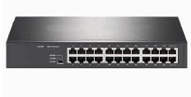
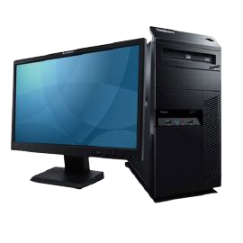
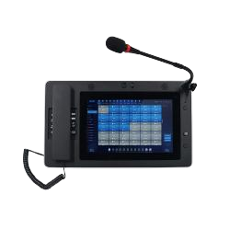
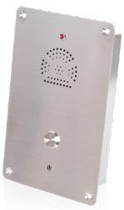
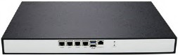
JR301-SC-IW-SIP JR301-SC-IW-SIP JR301-SC-IW-SIP JR301-SC-IW-SIP JR301-SC-IW-SIP
Server room
Control center
SIP Server
Cat5e
PoE Switch
Master station
Computer

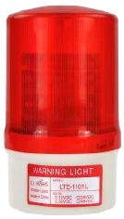
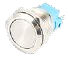

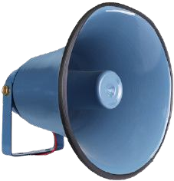
OPTIONAL ACCESSORIES
Button
Multiple Options Available
JR-LP-02
LED Beacon Light
JR-HSA-10/20/25/30/35
Broadcast Horn
JR321-SC
Telephone Pillar

APPLICATION SCENARIOS

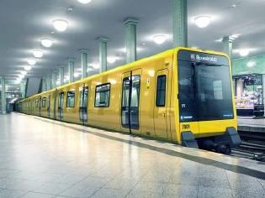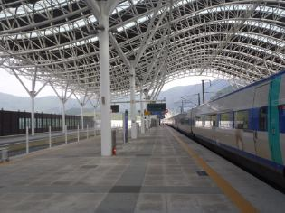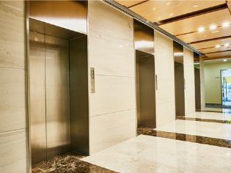

Metro Airport
Platform
Elevator

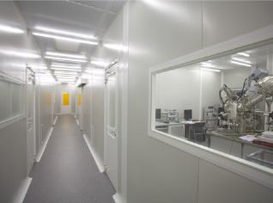

Clean room
Hospital
Bank
School

DIMENSIONS
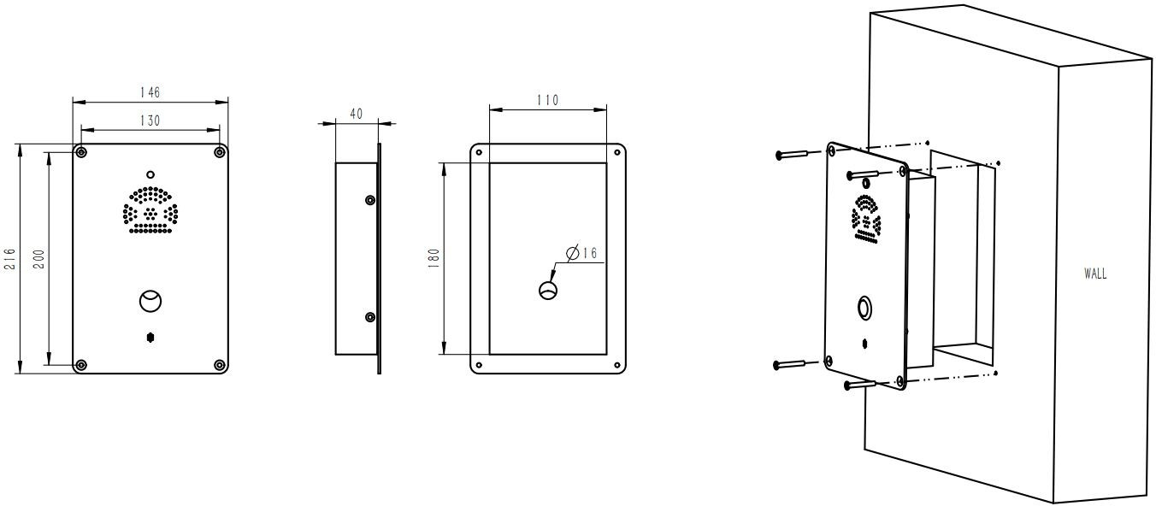

Package
Unit size | 216*146*40 (mm)
Shipping dimensions | 250*180*80 (mm)
Packaging materials | Foam padding, carton
Weight | Gross weight: 2 kg / Net weight: 1.5 kg


Add: 4325 Woodland Park Dr. West Melbourne, Florida. 32904
Email: info@tuffcomm.com
Tel: +1 321-900-4599
Web: www.tuffcomm.com

